A memorable place - London
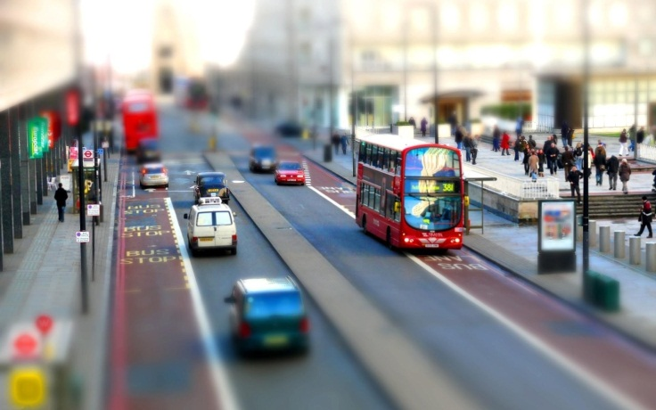
When people ask me about what city or town has made an impression, I’d think about one of the greatest cities in the world, London. London is in my opinion a place that has a rich culture, and has a notable type people. In this article, I’m going to explain why London has a place in my heart, and why I want to return.
It’s about two years ago, my dad and stepmom planned their wedding and honeymoon, and I was told that it’d take place in London. I was definitely having an additionally and an unusually excitement when I heard the news. Honestly I thought London was just a bunch of busy people in one place – fortunately I was wrong.
The story continues when I was about to step into the plane. I thought about all the things we were about to see. By the way, I travelled with my brother and my father. All of us had not experienced London yet. Heathrow Airport was nice unlike any other airport. I was about to believe how the Brits worked things out by the looks of architecture especially.
When we got out of the airport, you could really see how things reflected from the movies for instance, and the actual buildings. You see, in movies there’s always weight on the way people see the city, how the city’s streets are and so on and so forth – and it was actually true. London was just like in the movies, spectacular and sensational.
One thing that deserves a shout out is the infrastructure and transport. Taxies and busses are old, and by that I mean Londoners are terrific at keeping the way things are. And the best thing about this is that the city is not like completely old dilapidated, it’s hard to explain but it’s somehow innovative with ideas. In conclusion, I like the fact that their taxies are pitch black, and their busses are solid red.
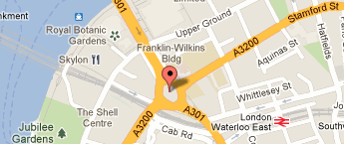
During this one-week vacation, we went to the greatest cinema, IMAX. It was the premiere of James Cameron’s success, Avatar. All of us were definitely satisfied with this visual achievement we got to experience. Walking along Oxford Street is like getting that daily steampunk injection. Each third building is either a restaurant or a Starbucks Coffee. In that regard, you can easily what’s being sold at high rates in London.
I wish I could point on a specific place that really had my attention, but it’s rather tough by the means of all the places I could choose from. London is a wonderful place to be. Will I return? Yes, but there’s a huge amount of other cities out there to be explored.

