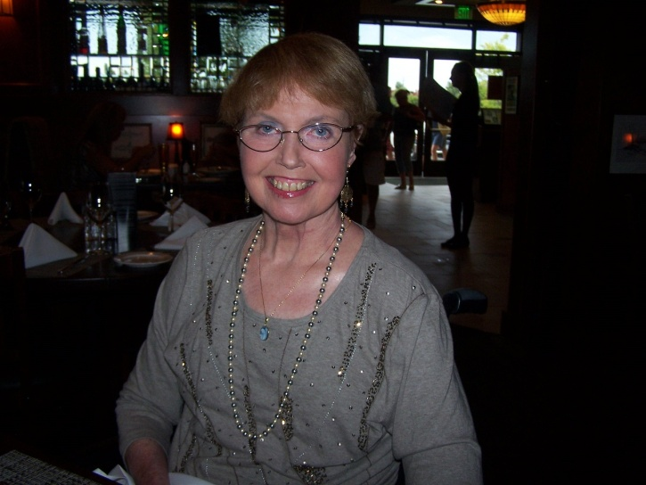
WOLFE, DONNA LEE
Born in Evanston, ILL ; passed away Dec. 1st, 2014, Sac, Ca.
She leaves behind her beloved husband Dennis Wolfe, of 47 years
Forever remembered by her son, Douglas Wolfe and wife Amy
and 3 grandchildren Kayla and Kyle, Skylar.
Will be deeply missed by all those that knew and loved her.
Donna battled with MS for 30+ years before finally
giving in.
She worked in Oncology, Dermatology at Kaiser along
with OB-GYN in the private sector.
Loved to travel with her "Sisters" to Mexico, read, and view the ocean .
She was also a soccer and baseball mom and helped in the hot dog shack.
All are welcome to her memorial services on
Sat, Dec 13th, 2pm at St. Joseph's Catholic Church, 280
Oak Tree Lane, Lincoln, Ca, 95648
In lieu of flowers please make donation to
National MS Society, 1700 Owens Street, Suite 190
San Francisco, CA 94185 In Memory of Donna L Wolfe

